Case Study

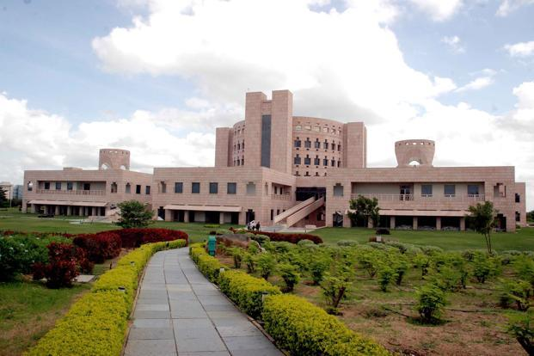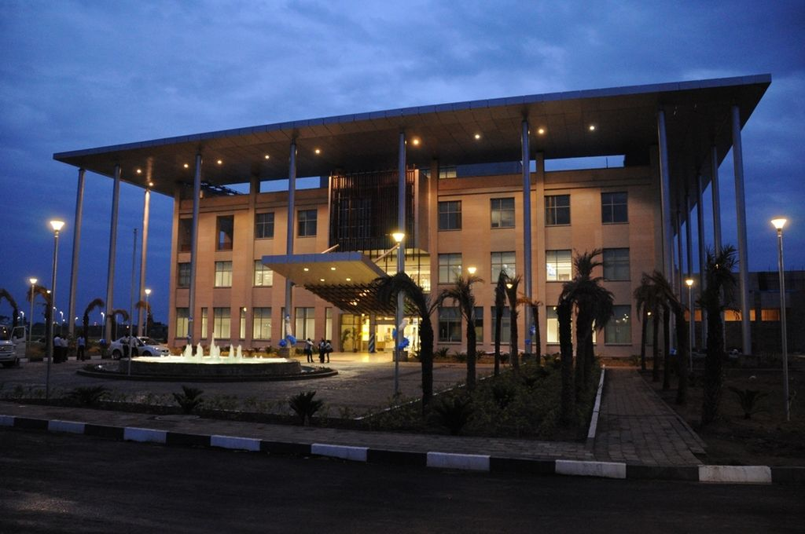

Organizational Structure:

Indian School Of Business

By

Ananya Mantravadi - CS19B1004

Gowtham Kancharla - CS19B1014

Siddharth Saini - CS19B1024

1. Brief History:

*The Indian School of Business is the manifestation of a bold idea that the Indian subcontinent could have a world class business school which hopes one day to be ranked right alongside of INSEAD of France.*

*- A Business India Report*

# *Indian School of Business’s PGP Ranks #7 Globally in the Forbes Best Business Schools 2019 Rankings and #1 in Asia.*

* *Forbes*

The Indian School of Business (ISB) is a private business school established in India in 2001. It has two campuses in Hyderabad (Telangana) and in Mohali (punjab).It offers a post graduate management programmes.

ISB was started in 1996 by a group of businessmen and academics. The Chief Minister of Andhra pradesh“Sri Nara Chandrababu Naidu” has sanctioned ISB’s Hyderabad campus in September 1998. The foundation stone was laid in 1999 and was inaugurated by Prime Minister Sri Atal Bihari Vajpayee in 2001.

**C-Founders**

1. Rajat Gupta (MD, McKinsey & Co)

2.Anil Kumar (Partner, McKinsey & Co)

**Formal Academic Partnerships**

1.Wharton Business School, Harton, USA

2.Kellogg School of Management, USA

3. London Business School, UK

4. MIT Sloan School of Management, USA

5.The Fletcher School, USA

Pramath Sinha, the junior partner at MCKINSEY in India was persuaded to take a leave of absence to be the school’s first Dean. Rajat Gupta became the School’s first Chairman and afterwards was succeeded by Adi Godrej. Current Chairman of the Board is Harish Manwani.

The idea of ISB was convinced in late 1995. The founder had a vision to create unique and enduring global, research–oriented and independent academic institution to nurture, train and transform the coming generations of students into future leaders and entrepreneurs of global stature.

ISB’s governing board was confirmed in early 1996, with Rajat Gupta, Managing Director of McKinney’s company as its Chairman. The Board comprised eminent business leaders representing diverse industries from both Indian and foreign corporates. An Executive Board with well-known business and academics personalities including Rahul Bajaj, Anil Ambani, Narayana Murthy, KV Kamath, MS Banga, YC Deveshwar, Adi Gogrej, Sumantha Ghoshal and others on it was also formed.

The founders faced several challenges while establishing the school. The selection of a site for the school was the first hurdle. The founders had to tackle the Indian bureaucratic system that is quite notorious for unnecessary delays in allowing new projects to get off the ground. Funding the total cost of the project which was estimated to be around $80-100 million (mn) was yet another challenge. However, generous donations from Indians settled in the US and other countries helped the founders raise the funds required to start the school.

ISB received generous support from corporates hailing from a world wide range of industries. Companies like Mahindra & Mahindra and Hindustan Lever Limited, extended their marketing support to ISB. Citi bank, McKinney’s and HSBC announced scholarships of meritorious students.

After a lot of deliberations over where the school should be set up, the founders decided they would opt for one of the larger metropolitan cities like Kolkata, Bangalore or Mumbai. They narrowed their choice down to Mumbai, as the city was regarded as the business capital of India. However, a political leader in Mumbai demanded reservation of seats for local students, and this made the founders look for an alternative venue.

In 1998, the founders visited Hyderabad, the capital of Andhra Pradesh (AP). They met AP’s chief minister, Chandrababu Naidu and learnt of his ambitious vision to make the state Asia’s knowledge hub. The founders finally decided to set up ISB in Hyderabad on a 250-acre plot of land. On September 6, 1998, ISB entered into an agreement with the Government of AP to setup the school. The site was identified in Gachibowli and construction commenced within a short time. The globally acclaimed US-based firm of architects, John Portman & Associates (JP&A), was selected to head the design team, while the UK-based WS Atkins oversaw the project locally. JPA designed the master plan within a year. The red tape was cut drastically through Chief Minister Naidu’s efforts and the school was ready, with all the amenities in place, within a short span of 21 months. Walt Miller, who supervised the project for JPA, said ― “Usually the red tape is significant in India, but the project was expedited by the top guy Chandrababu Naidu”. In June 2001, Pramath Raj Sinha (Sinha) was appointed as the dean of ISB.

In July 2001, the first batch of students joined the full-time Post Graduate Programme (PGP). The students are selected based on their general management Aptitude test (GMAT) scores, for both Indian and International students hailing from countries where English was not a medium of instruction, had to compulsory take the test of English as a foreign language(TOFEL), while Indian students were exempted from it.

2. Current Operations:

The B School offers various programmes with a vision of nurturing young Business Leaders in the field of management education. These programmes give students a strong exposure to global best practices while being firmly embedded in an emerging markets context, focusing on managing business in erratic environments*.* A research-oriented Global faculty pool, global curriculum, high level of corporate input through Industry Guest lectures and workshops, innovative pedagogical methods enable students to maintain their edge. The ISB curriculum is enriched through input provided by corporations. This association allows the School to foster stimulating business-academic partnerships for teaching, research and exposes students to industry perspectives. The following are the different categories of all the programs:

Long Duration Programmes:

* **Post Graduate Programme in Management**

It is a one-year percipient programme designed for professionals with at least two years of post-qualification work experience who want to study management. This programme helps you learn the traditional MBA in a customised format. The goal is to transform present day mid-career professionals to global business leaders of tomorrow.

* **Post Graduate Programme in Management for Working Professionals**

PGPpro is targeted at working professionals and business owners, with 5 to 12 years of work experience who desire to consolidate their functional career, and aspire to go on to senior management roles thereafter. This programme enables the individual to enhance their decision-making, gain understanding strategies, develop leadership skills as well as strengthen their managerial roles.

* **Post Graduate Programme in Management for Senior Executives**

ISB's PGPMAX is a 15 month, Global Executive MBA level programme designed with an objective of meeting higher career aspirations of experienced professionals and business owners/entrepreneurs with 10 to 25 years of work experience. With a goal to inculcate analytical, strategic and leadership skills that are essential to navigate in today's evolving business world, it assists an individual in his/her career advancement.

* **Fellow Programme in Management**

FPM is designed for individuals who are keen about research and learning and are looking for pursuing an academic career. Its objective is to groom promising young researchers to be innovative problem-solvers and thinkers in the business disciplines of Accounting, Financial Economics, Information Systems, Marketing, Operations Management, Organisational Behaviour and Strategy, which are niche areas at the ISB.

* **Executive Fellow Programme in Management**

The Executive Doctorate in Business Administration level programme is for experienced business leaders and faculty without doctorate who hold a bachelor’s degree and have extensive work experience but do not want to leave their careers to pursue a full-time PhD or FPM. This is for individuals who seek to deepen their understanding of latest business theory and apply it to address modern challenges of today’s dynamic business environment

* **Post Graduate Programme in Management for Family Business**

PGP MFAB is a 15 month programme designed for the next generation of family business owners, with a curriculum taught from an owner’s perspective. The individual is exposed to diverse learning opportunities through interactions with global faculty, international exposure, industry interventions, experiential learning and more.

All the above Programmes have a highly competitive selection process, and only the very best of the candidates graduate.

Executive Education:

The Centre for Executive Education at ISB provides working professionals with programmes to help them upgrade and improvise in their domains, while aiding the organisations they operate in. Sophisticated programmes covering many areas of business are available for different seniority levels and geographical sites. They are classified as:

* **Advanced Management Programmes**

ISB Centre for Executive Education offers Advanced Management Programmes for working professionals. The curriculum comprises the latest research in the respective fields and aims to provide participants with a comprehensive knowledge of the domain. These are categorised into:

* Advanced Management Programme in Business Analytics
* Advanced Management Programme in Public Policy
* Advanced Management Programme for Healthcare
* Advanced Management Programme for Infrastructure
* Advanced Management Programme for Manufacturing and Operations
* **Open Programmes**

These enrollment programmes which are focused on general management, strategy, sales & marketing, digital transformation, governance, etc. are open to everybody with the target of upgrading executives to the latest trends and equipping them with skills and knowledge to address real-life business world problems.

* **Custom Programmes**

These programmes are designed specifically to deliver precise learning solutions that boost the business performance and growth of the organisation.

* **Course in Strategic Retail Management**

CSRM is an intensive programme, designed to enhance leadership in the context of Indian retail. This programme enables participants to evaluate their own retail strategies, discover newer models from international markets and explore various challenges that are synonymous with this industry.

Massive Open Online Courses:

ISB delivers its Massive Open Online Courses in partnership with Coursera. It is India’s first Indian collaborator to produce and own content that is served online to learners internationally. The courses offered are:

* Financial Markets and Investment Strategy Specialization
* A Life of Happiness and Fulfilment
* Trading Strategies in Emerging Markets Specialization
* Business Technology Management Specialization

Technology Entrepreneurship Programme:

The TEP is a one-year long programme tailored specifically for engineering students to imbibe entrepreneurship skills, mentor and support them.The initiative also inculcates hard business skills to create and manage new ventures using design thinking and practical tools for translating engineering to commercial products.

Events:

ISB hosts diverse national and international events throughout the year as a part of their mission to engage with business, government and society. These events include research seminars, workshops, admission information sessions, industry events, conferences, speaker sessions, group visits, student engagements, competitions, social events, and so on.

Research:

Research is top-notch at ISB, with the faculty following the tenure track much like their counterparts in top business schools worldwide. They have published in over 70 top-tier journals in different management areas. Some of the areas where the ISB faculty have been conducting research and have published are: Strategy, Organizational Behaviour, Finance and Economics, Information Systems, Marketing, and Operations Management. The ISB is among the few schools in the world that undertake research with a focus on emerging and transition economies, striving to create synergies between India, Asia and the global business environment.

3. Complexity:

*Organizational Complexity* is how multiple entities of an organization differentiate among themselves. It refers to the number of resources that are involved in a division, project, or team.

Overall Complexity:

The overall complexity of the institute can be explained by the flow chart given below:

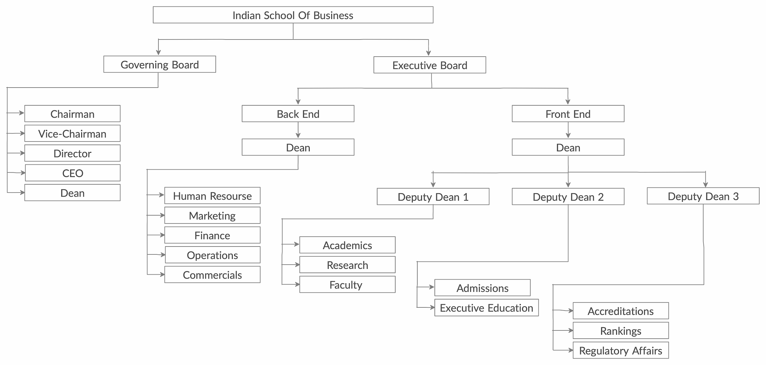

The institute is governed by two boards: Governing and Executive.

The Governing Board Comprises of various eminent persons from Global Corporations, and the Deans of the Academic Partner Schools. The Executive Board is comprised mainly of CEOs of Large Indian Corporates. The School’s operations are handled by The Front End and The Back End. The Front End is Headed by three Deputy Deans with different works as explained in the flow chart and centralization. The Back End works mainly for the smooth running of the institute and its upliftment.

Designations Of Faculty:

The Faculty in the ISB can be divided into 4 categories, namely:

1. Permanent Faculty
2. Visiting Faculty
3. Visiting Scholars
4. Faculty Alumni

These 4 categories are further divided into 6 designations:

1. Professor
2. Associate Professor
3. Assistant Professor
4. Clinical Professor
5. Clinical Associate Professor
6. Clinical Assistant Professor

The flow chart explains the above distribution:

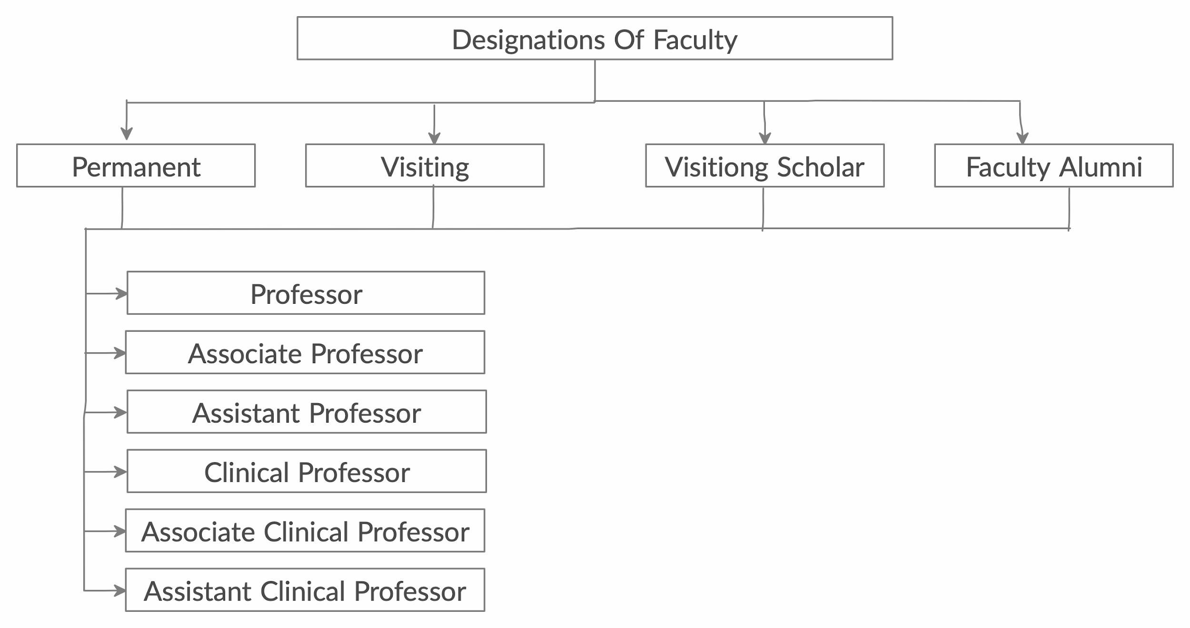

Graduate Student Board:

The GSB is the primary vehicle for coordinating and managing student activities and initiatives, both academic and extracurricular. It represents the interests of PGP students in the Indian School of Business (ISB) administration.

It is comprised of the members elected by the Graduate Student Association.

The flow chart explains the various designations in the Board:

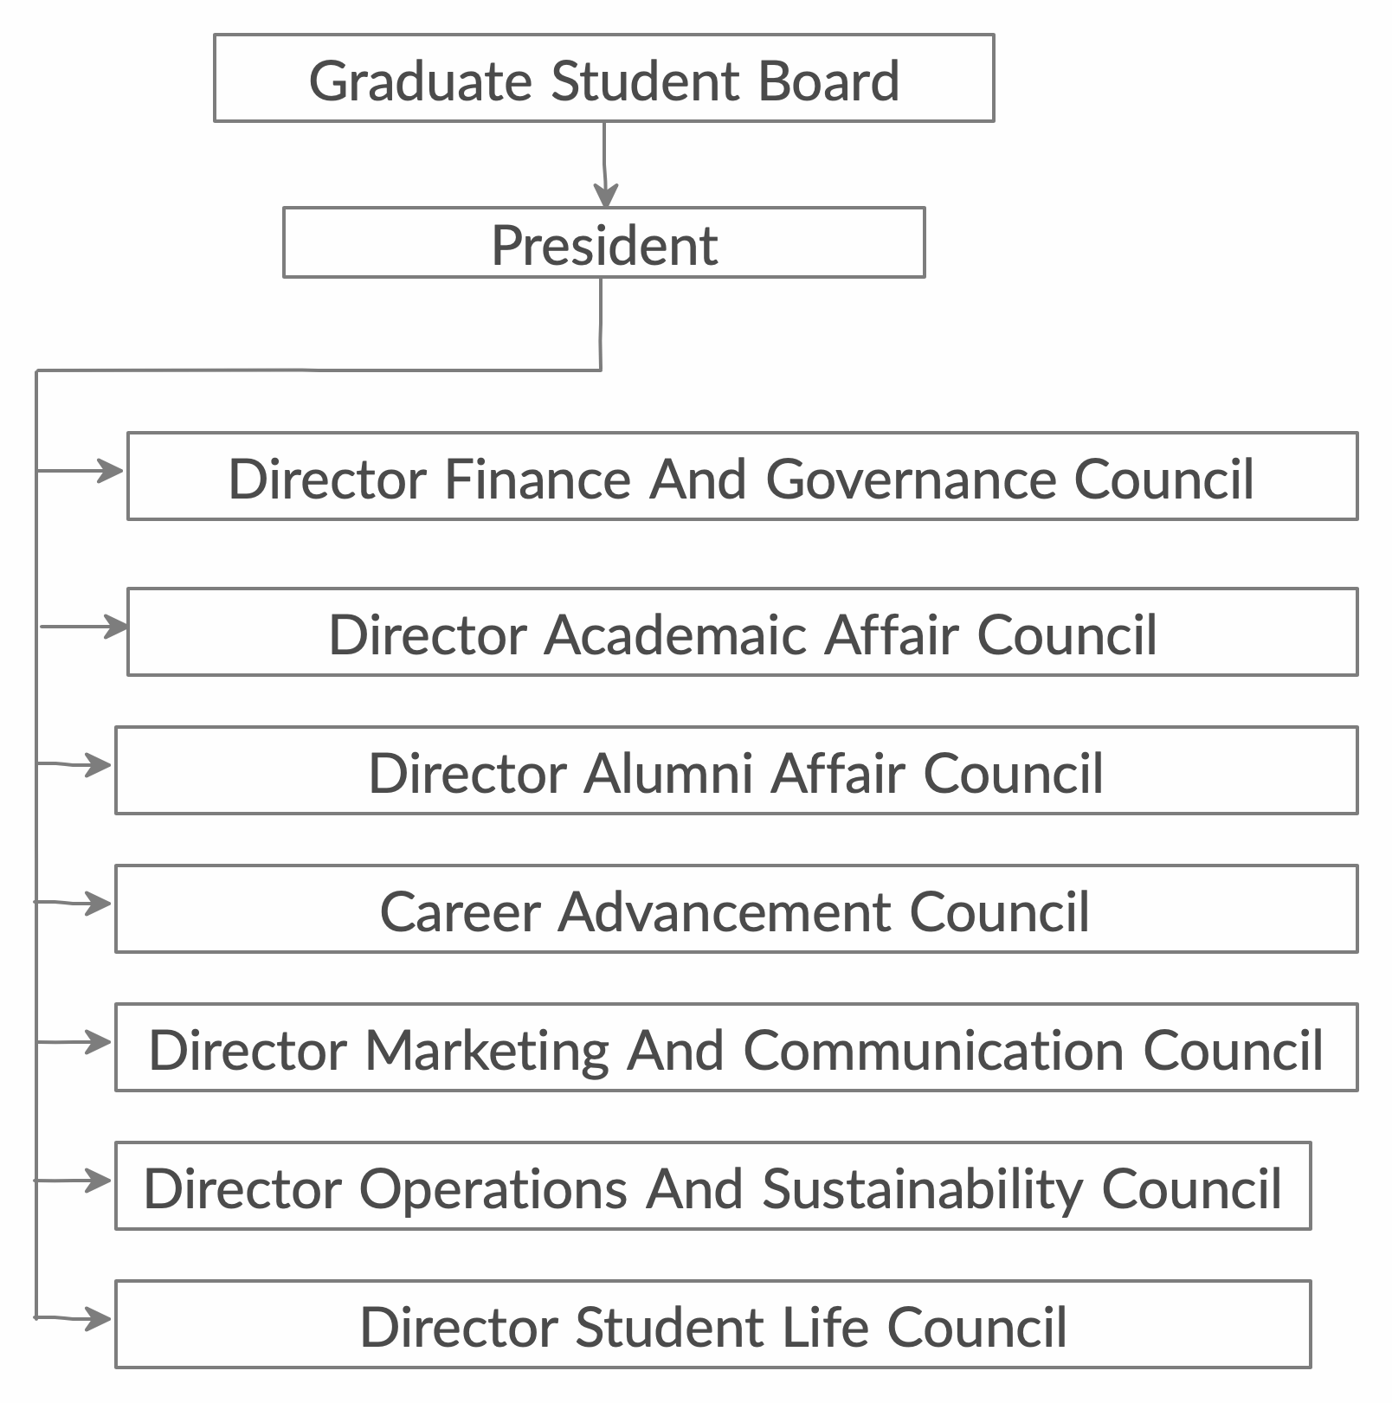

Student Clubs:

There are two kinds of student clubs - Professional Clubs and Social Clubs.

1. Professional Clubs:

* [Business Technology Club](https://www.isb.edu/business-technology-club)
* [Consulting Club](https://www.isb.edu/consulting-club)
* [Energy Club](http://www.isb.edu/energy-club)
* [Entrepreneurship & Venture Capital Club](https://www.isb.edu/entrepreneurship-vc-club)
* [Finance Club](https://www.isb.edu/finance-club)
* [Healthcare Club](https://www.isb.edu/healthcare-club)
* [Manufacturing & Operations Club](http://www.isb.edu/operations-and-manufacturing-club)
* [Marketing Club](https://www.isb.edu/marketing-club)
* [Net Impact Club](https://www.isb.edu/net-impact-club)
* [Public Policy Club](https://www.isb.edu/public-policy-club)
* [Retail and e-commerce Club](https://www.isb.edu/retail-club)
* [Senior Executive Club](https://www.isb.edu/senior-executive-club)
* [SREI Infrastructure Club](https://www.isb.edu/srei-infrastructure-club)
* [Toastmasters Club](http://www.isb.edu/toastmasters-club)
* [Women in Business Club](https://www.isb.edu/women-business-club)

1. Social Clubs:

* [Arts & Creativity Club](https://www.isb.edu/arts-creativity-club)
* [Dance Club](https://www.isb.edu/dance-club)
* [Music Club](https://www.isb.edu/music-club)
* [Photography Club](https://www.isb.edu/photography-club)
* [Quiz Club](https://www.isb.edu/quiz-club)
* [Radio Club](https://www.isb.edu/radio-club)
* [Sports Club](https://www.isb.edu/sports-club)
* [T](https://www.isb.edu/wine-brew-club)[heatre Club](http://www.isb.edu/theatre-club)

Campus Map:

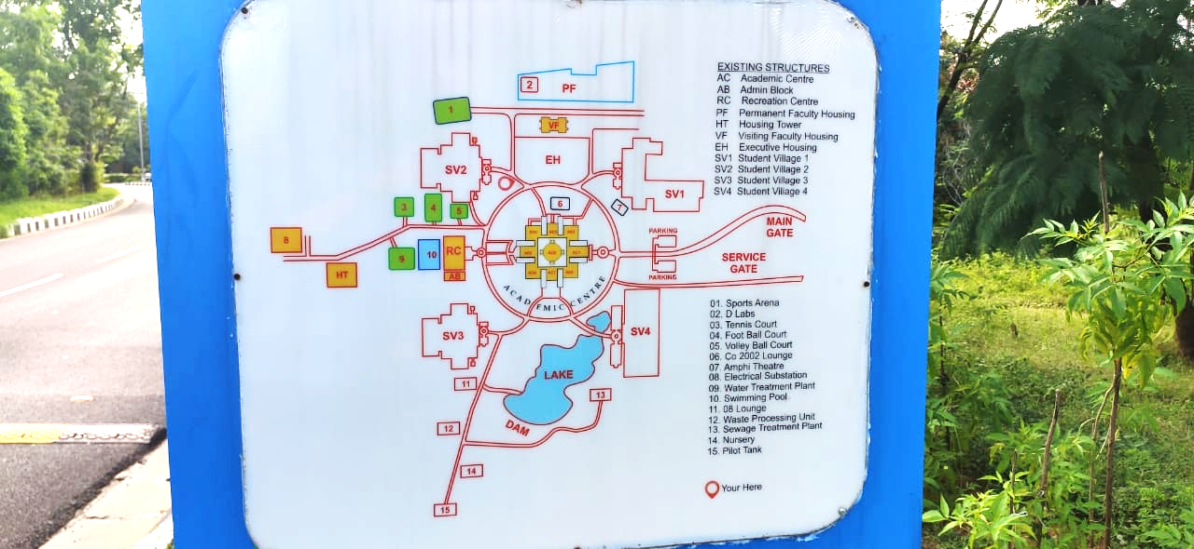

4. Centralization:

Centralization deals with the degree to which the formal authority to make discretionary choices is concentrated in an individual, unit, or a level. It refers to the hierarchical level within an organisation that has authority to make decisions.

The mission and objectives for ISB are set by the Executive and Governing Boards. All the decisions beyond the master project plan at ISB are handled or approved by them, and are advisory in nature. The Executive Board reviews quarterly while the Governing Board reviews annually. The Governing Board consists of heads of the Fortune 500 companies, renowned entrepreneurs and academics who have contributed time, thought and resources towards establishing the School. The Chairman of the Board is directly responsible for ensuring that the Dean and the School will perform as per the Objectives set by the Board. New policies are initiated and framed by Dean, for all operational matters.The organisational configuration at ISB follows a divisional structure.

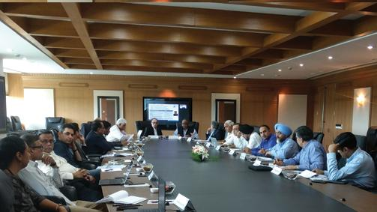

The following is a list of the members of the Boards:

|  |  |  |  |
| --- | --- | --- | --- |
| **NAME** | **DESIGNATION / ORGANISATION** | **NAME** | **DESIGNATION / ORGANISATION** |
| Rajendra Srivastava | Dean and Novartis Professor of Marketing Strategy and Innovation - ISB | Mark Moody-Stuart | Former Director - HSBC Holdings Plc |
| Harish Manwani* | Chairman of the Board - ISB  Former Chairman - Hindustan Unilever Limited  Senior Operating Partner -Blackstone | Pawan Munjal* | Managing Director and CEO - Hero MotoCorp Limited |
| Anil Ambani* | Group Chairman & CEO - Reliance Group | Vinod Gupta | Managing General Partner - Everest Group, LLC |
| Bernard Arnault | Chairman and CEO - LVMH Moët Hennessy Louis Vuitton S.E | Kathleen Hagerty | Interim Dean - Kellogg School of Management |
| Rahul Bajaj | Chairman - Bajaj Auto Limited | Sunil Kant Munjal* | Chairman - Hero Corporate Service Limited |
| Manvinder S.Banga | Operating Partner - Clayton, Dubilier & Rice, LLC | James R.Murdoch | Chief Operating Officer - 21st Century Fox |
| Scott R.Bayman | Chairman Emeritus and Senior Advisor - Lumis Partners | N R Narayana Murthy | Founder - Infosys Limited |
| Neeraj Bharadwaj* | Managing Director - Carlyle Group, India | Lakshmi Narayanan | Former Vice Chairman - Cognizant Technology Solutions |
| Lloyd C Blankfein | Former Chairman and CEO - The Goldman Sachs Group Inc. | Sanjay Nayar* | CEO - KKR India |
| Ronnie C.Chan | Chairman - Hang Lung Group Limited | François Ortalo-Magné | Dean- London Business School |
| Purnendu Chatterjee* | Founder and Chairman - The Chatterjee Group | Vikram S. Pandit | Former Chief Executive Officer - Citigroup Inc. |
| Keki Dadiseth* | Non-Executive Chairman - Omnicom India Marketing Advisory Services Pvt. Limited | Deepak Parekh | Chairman - HDFC Limited |
| Michael S.Dell | Chairman and CEO - Dell Technologies | Rajendra Pawar* | Chairman and Co-Founder - NIIT Group |
| Jurgen Fitschen | Former Co-CEO - Deutsche Bank AG - Deutsche Bank AG | The Kok Peng | Chairman - Ascendas Pte Ltd |
| Geoffrey Garrett | Dean - The Wharton School | GV Prasad* | Co-Chairman & CEO - Dr. Reddy's Laboratories Limited |
| Adi Godrej* | Chairman- Godrej Group | Atul Punj* | Chairman - Punj Lloyd Group |
| Prabhu Goel | Founder and Former Chairman - Signet Solar Inc. | Srini Raju* | Managing Director and Co- Founder - Peepul Capital |
| Vinita Gupta | Founder - Quick Eagle Networks Inc. | Girish Reddy* | Member and Co-Founder - KKR, Hedge Funds |
| Urs Hofmann | Member of the Executive Board - Credit Suisse Group AG | Arun Sarin | Director - Ondot Systems, Inc. |
| Pramit Jhaveri | CEO - Citi India | David Schmittlein | Dean - MIT Sloan School of Management |
| Uday Khemka | Vice Chairman - SUN Group | Ajay Shah | Managing Partner - Shah Capital Partners, LP |
| Vinod Khosla | Founder and Partner - Khosla Ventures, LLC | MK Sharma* | Chairman - Thomas Cook (India) Limited |
| Rahul Khosla* | President - Max Group | Analjit Singh | Founder and Chairman - Max Group |
| Chanda Kochhar | Former Managing Director and CEO - ICICI Bank Limited | KP Singh | Chairman of the Board - DLF Limited |
| Arjun Malhotra | Chairman Emeritus - Headstrong Corporation | Pramath Raj Sinha* | Founding Dean - ISB  Founder and Managing Director - + 9.9 Mediaworx Pvt Limited |
| Kiran Mazumdar-Shaw | Chairman and Managing Director - Biocon Limited | Charles Miller Smith | Former Senior Advisor - Warburg Pincus |
| Aman Mehta | Former Chief Executive Officer - HSBC Limited | Martin Sorrell | Former Chief Executive Officer - WPP Group Plc |
| Sanjiv Mehta* | Chairman and Managing  Director - Hindustan Unilever Limited | Mallika Srinivasan* | Chairman and CEO - Tractors and Farm Equipment Limited |
| Victor Menezes | Senior Operating Advisor - New Silk Route Partners, LLC | James Stavridis | Dean - The Fletcher School |
| Lakshmi Mittal | Chairman and CEO - ArcelorMittal | Sanjay Subhedar | Managing Director - Storm Ventures, LLC |
| Sunil Bharti Mittal | Founder & Chairman - Bharti Enterprises | Marti G. Subrahmanyam* | Charles E. Merrill Professor of Finance and Economics, Stern School of Business & Global Network Professor of Finance and Economics - NYU Shanghai New York University |
| Rakesh Bharti Mittal* | Vice-Chairman and Managing Director - Bharti Enterprises | Rana Talwar | Founding Chairman and Managing Partner - Sabre Capital Worldwide Inc. |
| Romesh Wadhwani | Founder, Chairman & CEO - Symphony Technology Group | Jacob Wallenberg | Chairman of the Board - Investor AB |
| Yoshihiko Miyauchi | Chairman and CEO - Orix Corporation | Daniel Vasella | Former Chairman of the Board - Novartis International AG |
| Arshad Zakaria | Chief Executive and Founder - New Vernon Capital, LLC | Peter Zencke | Former Executive Board Member - SAP AG |

*Also Members of the Executive Board

Academic Design and Delivery(Front End Administration)

Under the overall supervision of the Dean, the three Deputy Deans administer different academic related areas. The Research Centres and Institutes (RCIs) are a forum where knowledge and business understanding are exchanged between the academics and the corporate. The Centres are completely under ISB’s regulations while Institutes are co-funded by other companies. Executive Directors of respective Centres get their budgets and goals or targets approved by the committee comprising Dean and Deputy Deans:

* Professor Rajendra Srivastava: *Dean*

Novartis Professor of Marketing Strategy and Innovation

* Professor Sanjay Kallapur: *Professor of Accounting*

Deputy Dean - Planning & Regulation FPM/ EFPM

Academic Director - IEMS

* Professor Milind Sohoni: *Area Leader and Professor of Operations Management*

Deputy Dean - Hyderabad Campus

Deputy Dean - Academic Affairs

* Professor Phil Zerrillo: *Practice Professor of Marketing Strategy*

Deputy Dean - Corporate and International Relations

Deputy Dean - Mohali Campus

* Professor Chandan Chowdhury: *Practice Professor of Operations Management & Information Systems*

Senior Associate Dean - Career Advancement Services (CAS)

Executive Director - Munjal Institute of Global Manufacturing(MIGM) & Punj Lloyd Institute of Infrastructure Management (PLIM)

* Professor Ramabhadran Thirumalai: *Associate Professor of Finance (Practice)*

Senior Associate Dean - Academic Programmes

* Professor Anand Nandkumar: *Associate Professor of Strategy*

Research Director - CIE

Associate Dean - RCI Management

* Professor Sudhir Voleti: *Associate Professor of Marketing*

Associate Dean - Faculty Alignment and Registrar's Office

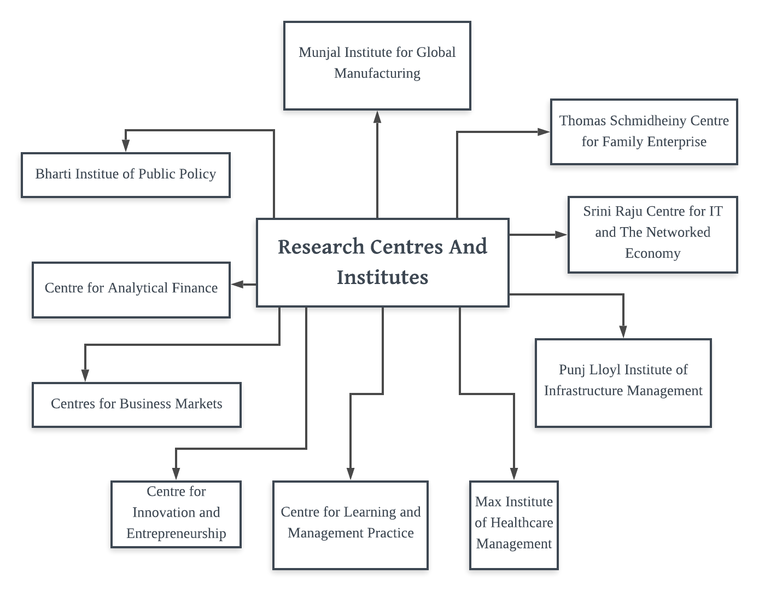

Administration(Back End Departments)

The day-to-day operational workings are taken care of by the Back End Departments, which work under their corresponding Directors and are headed by the Dean:

1. HR - It is the division that is focused on the activities relating to the employees such as recruiting, training, promoting, and so on.
2. Operation - Also known as the Facility Management, it deals with overall management of campus and the physical assets including food provision, accommodation, maintenance, etc.
3. Commercials (Purchase) - It is involved in negotiating with vendors and purchasing commodities at the right price.
4. Marketing - This division manages activities of promoting products or services, including market research and advertising.
5. Finance - The management of money like investing, borrowing, lending, budgeting, saving, and forecasting are handled by this division.

5. Formalization

Formalization in organizational structure is a process in which managers specify (in writing),procedures, rules and responsibilities for the individual employees, organizational units, groups, teams and the organization as a whole, which leads to the development of processes, relationships, and operating procedures

**Procedures**

**Eligibility for FPM**

Candidates must hold a university degree from an accredited academic institution. Applicants typically should have an undergraduate/postgraduate degree in areas such as business, economics, engineering, computer sciences, mathematics, physics or the arts. Designed for individuals who have a passion for research and learning and are keen to pursue an academic career.

**Eligibility for PGP**

There are 2 stages that a candidate goes through before getting selected for MBA Program.

* Candidates are required to appear for the GMAT exam. Candidates are shortlisted based on their performance in the exam.
* The shortlisted candidates are called for a round of Personal Interview. Based on their performance in the interview the selected candidates are offered a seat at ISB. An incisive one-year programme designed for mid-career professionals.

**Eligibility for MFAB**

* The candidates should have completed a Bachelor's Degree or an equivalent qualification (like CA etc.) at the time of submitting the application.
* No work experience is required for admission. However, the ISB strongly feels that an experience of 4-5 years will add a lot of value

Applications are invited based on which a candidate is shortlisted. The shortlisted candidates are called for a round of Personal Interview. Based on their performance in the interview and the BAT exam the selected candidates are offered a seat at ISB.

**Eligibility for PGPMAX**

* The candidate should have a bachelor’s degree or an equivalent qualification in any discipline. An equivalent qualification will be determined by the Admission Committee of the programme and will include the likes of CA, ICWA, etc.
* The candidate should possess a minimum of 10 years of full-time work experience as on the date of submitting the application (desired experience is closer to 15 or more years).
* Applications are invited based on which a candidate is shortlisted.
* Shortlisted candidates will be called for a round of Personal Interview. Interviews will be held in person whenever possible and may be conducted via teleconference or video conference facilities in some cases.

**Accreditations**

ISB is accredited with the ASSOCIATION TO ADVANCED COLLEGIATE SCHOOLS OF BUSINESS (AACSB), The EFMD Quality improvement system (EQUIS), a non-profit membership organization that provides a quality certification to its member schools and their programs. Both AACSB and EFMD are internationally acclaimed accreditation institutions focused on raising the standards of management education worldwide. ISB joins the group of about a hundred selected business schools worldwide that have both AACSB and EQUIS.

The institutions focus on internationalization and ethics, it connections with the corporate world, and how it balances between academics and managerial relevance. The accreditations reflect ISB’s position as a pivotal role which will lead global management education landscape. ISB was the first business school in south Asia to get the AACSB accreditation in 2011 and re –accreditation in 2017.

**Affiliations**

The Max Institute of Healthcare Management aims to be a transformative force in the Indian healthcare sector creating value, within India and beyond, through the three integrated elements of research, education, and outreach. Thematically the Institute works in the area of Management of Healthcare Delivery Institutions, Financing of Healthcare and Healthcare Policy, Innovation and Entrepreneurship and Patient Centricity. The Institute aims to be the leading voice, supporting and providing value to the public and private sectors, and the technology startups creating a positive impact in the rapidly growing Indian Healthcare sector.



The health care management department is the Wharton school’s base for scholarship, education and innovative thinking related to the business management and policy of health care service, healthcare technology, and health care financing. The department sponsors three educational programs:

1 .The PHD health care management and economics

2. The MBA program in health care management

3. BS in economics with a concentration in health care management and policy

ACCESS Health International is a nonprofit think tank, advisory group, and implementation partner with a mission to improve access to high quality and affordable healthcare for people everywhere, no matter what their age. We work in close collaboration with governments, the private sector, development partners, and researchers to improve health financing systems and the quality of healthcare services in low, middle, and high income countries.



DLabs is the incubation and acceleration arm of Indian School of Business set up in collaboration with the Department of Science and Technology, Government of India. It aims to support the creation of a vibrant and high impact entrepreneurial ecosystem focused on innovation in key sectors including technology commercialization. DLabs leverages the vast resources, expertise and networks of Centre for Innovation and Entrepreneurship at ISB through mentorship, education and investor connect.

**POLICIES**

CASHD - Policies against sexual harassment and discrimination

The Indian School of Business (ISB) is committed to creating an environment free of any discrimination based on age, caste, creed, color, disability, gender, nationality, religion, sexual orientation. ISB employment policies are already geared toward this end. ISB expects its students and employees to maintain highest behavioral standards and norms and hopes that deviations would be rare or non-existent. For this purpose, ISB has the Committee against Sexual Harassment, Discrimination & Harassment (CASHD).

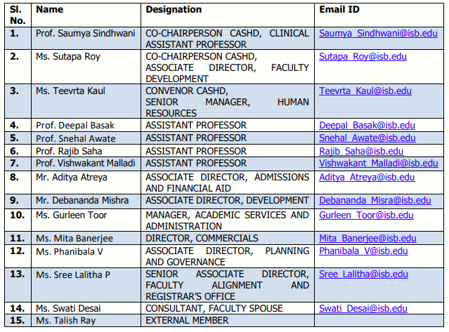

7. References:

1. Dr. Ganesh Seshan, Senior Associate Director - Human Resources, ISB
2. Dr. K N Rekha, Senior Faculty, MGNCRE, MHRD, DHE, GOI, Hyderabad
3. Dr. M P Ganesh, Associate Professor, Liberal Arts Dept., IIT Hyderabad
4. [https://www.isb.edu](https://www.isb.edu/pgp/student-clubs)
5. <https://en.wikipedia.org/wiki/Indian_School_of_Business>
6. A Leading Business School in India.pdf (BSTR106) of year 2004
7. <https://www.forbes.com/business-schools/list/international-1-year/#tab:rank>
8. <https://www.isb.edu/sites/default/files/Ver-0.1-2019_-Policy-against-Sexual-Harassment-and-Discrimination-Sep-2019.pdf>

Visit To ISB:

